**Report with recommendations from**

**NorCRIN Work Package 11**

**Organisational units to support clinical trials**

**"Infra"**

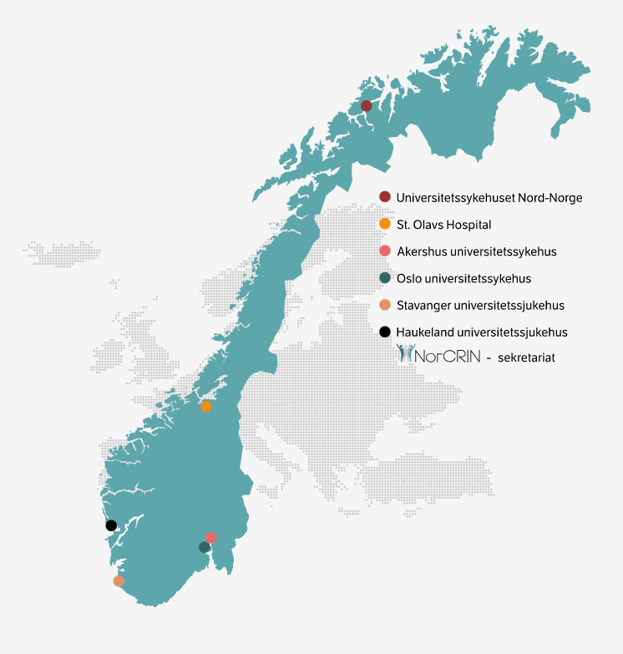**Organizational units for the conduct of clinical studies**

Content

Introduction 3

Summary of work 3

Conclusion and recommendations 4

Summary of the recommendations 5

Infrastructure 5

Competence 7

Save time for the clinician/researcher 7

Quality/internal control 8

Other 8

Further work 9

Appendices 9

**Version history**

|  |  |  |
| --- | --- | --- |
| Version | Alteration | Date |
| 0.x | First version, made for the AG Mapping meeting on 27 May 2021. And various later revisions, see the version history of version 1.0 | May 26, 2021 |
| 1.0 | Version sent for review in and outside NorCRIN in June 2024 | Jun 9, 2024 |
| 2.0 | Version where the input from June has been included, and which was put out for review in August/September 2024. | Aug 15, 2024 |
| 2.1 | Version 2.0, but with the Summary section added. | Aug 27, 2024 |
| 2.5 | Version where the input from September 2024 has been included | Oct 22, 2024 |
| 3.0 | Makes a short summary of the mandate, conclusion and recommendations from V2.5. Rename V2.5 to a sub-report, and attach it as a supplementary document to the report. | March 13, 2025 |
| 3.0 English | An English version of the report 3.0 | Apr 1, 2025 |
|  |  |  |

# Introduction

This report provides a set of specific recommendations for support for the Faculty of Humanities and hospitals that wish to establish or further develop their own infrastructure for research support. The recommendations are based on a survey of research support in Norway and abroad, see Appendices 1 and 2. This report with recommendations constitutes an important part of the deliverables from Work Package 11 (WP11) in the NorCRIN2 project. The work is/will be carried out in the period 2020-2025. AP11 wants the report to be relevant both within and outside the NorCRIN network. The recommendations will be updated as the follow-up work progresses.

In a number of countries, networks of different types of research support units have been developed to strengthen the focus on clinical research. The mandate of WP11 is to map research support units nationally and in relevant countries outside Norway, including the Nordic countries. WP11 will propose the types of organisational units (including services and capacity) that would be appropriate to develop in Norway, so that we can collaborate effectively in national and international studies.

WP11 will build on the work done in NorCRIN1, in particular the work on early-phase units (WP7), and other work done in Norway to establish, for example, clinical research posts and research support units (Clinical Trial Units (CTU) and similar).

NorCRIN is part of the European research infrastructure ECRIN (European Clinical Research Infrastructure Network), and ECRIN studies are important international studies for Norwegian academic trials. ECRIN has therefore been a key source of information when WP11 has collected information about how "the world out there" has been organised. In light of the National Action Plan for Clinical Trials (from January 2021), the Nordic Region has been given a special focus.

# Summary of work

The overall goal of WP11 is to contribute to increasing the number and quality of clinical trials in Norway, and to strengthen research collaboration nationally and internationally.

WP11's operational objective is to contribute to the further development of various research support units, regardless of current organisation/experience/capacity.

WP11 has mapped research support in Norway and abroad, with the aim of finding out whether there are common standards and best practice in countries with which it is natural to compare ourselves, and which WP11 will therefore recommend to be implemented in Norway. The information gathering has therefore focused on the situation and status as of today. See Appendix 3, sub-report, which documents much of the work in WP11, and elaborates on the current situation and important challenges, which form the basis for the recommendations.

WP11's delivery/end product, according to the mandate, is to create a "*national recommendation/standard/competence requirement for different types of services, roles and units (e.g. research posts, research support units and other types of units) that will be part of the infrastructure for clinical research that contributes to clinical trials. It will also be natural to look at network structures that ensure coordination and cooperation between such units.*

*Standardisation is an important objective of WP11. Standardization ensures predictability and reduces transaction costs between collaborating entities. It will be considered whether a formal national certification/accreditation should be proposed*."

In this report, WP11's main focus has been on services, but also on cooperation, financing, development of expertise, quality and other factors. For resource reasons, the focus of the work has been on services from units that provide what we have called "administrative" research support, i.e. units that provide research support - but do not have direct contact with patients/study participants. To some extent, services from research posts and R&D units out in the clinic/division are also discussed, and we will consider whether the work in the future should provide a broader coverage of such units. A key point is that it is the joint support of these units to researchers and study groups that is important. The units are part of what we in WP11 have referred to as infrastructure for research support, as shown in the figure below.

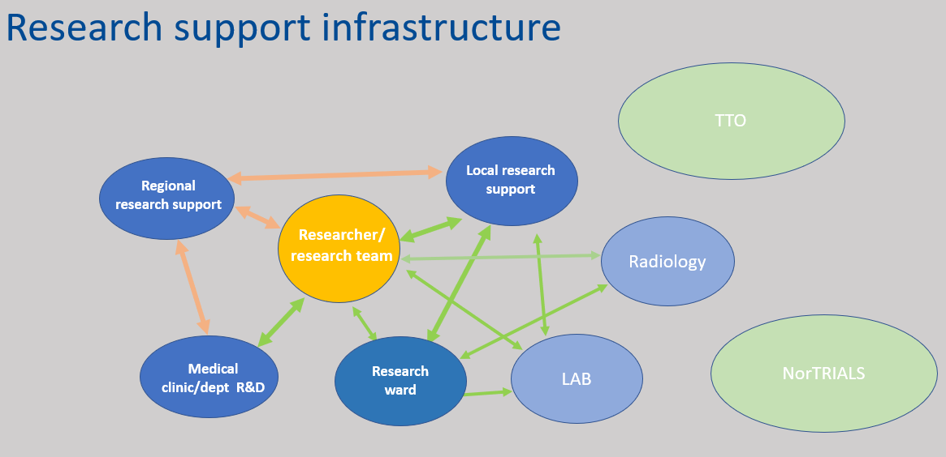

**Figure 1: The infrastructure for research support, which will collectively provide the necessary support to the researcher/study group**

# Conclusion and recommendations

The impression after visits to research support units in Sweden, Denmark, Switzerland and Germany is that the infrastructure for research support has developed organically, i.e. based on local needs and initiatives, and to a lesser extent on the basis of overarching/national guidelines. We find many common features between the countries, but a lower degree of "standardisation" of services and organisational structure than expected. There are therefore no clear standards to refer to as a basis for our recommendations. WP11 therefore does not currently consider it nescessary to establish any form of national accreditation scheme for units in the infrastructure for research support to meet the expectations of sponsors/responsible institutions for academic studies abroad.

There is an ongoing debate about factors that affect the number of clinical trials at Norwegian hospitals. In 2024, there is a consensus that clinicians' time will become an increasingly scarce resource. Assistance and competent follow-up from research support, which can save time and reduce administration for the individual researcher, will thus be a very important factor that can contribute to more researchers wanting to conduct clinical trials. In addition, increased use of new technology and digitalisation leads to an increased need for IT expertise in research support.

## Summary of the recommendations

The recommendations are divided thematically, and we have chosen the following topics/areas: infrastructure, competence, saving time for clinicians/researchers, quality/internal control, and others.

### Infrastructure

**Collaboration across health trusts and regions:** WP11 recommends a "ladder" with 4 levels of services and expertise that must be in place, either locally, regionally or nationally, to be able to participate in clinical trials – with increasing demands for competence and experience.

**Fig. 2: Levels of research support**

Levels of research support:

* Level 1: Local centres participating in national multicentre studies need basic support and facilities, including a good understanding of the protocol and applicable laws and regulations, processes for local anchoring at PVO, etc., systems for obtaining consents and storing documentation, sampling and storing samples. Support staff dedicated to clinical trials.
* Level 2: Institutions that act as sponsors for simple clinical trials must have competence and capacity equivalent to level 1, and be able to design and carry out the study in accordance with protocols, including taking care of all sponsorship tasks.
* Level 3: As a sponsor of national multicentre studies, the institution must have experience at levels 1 and 2, and have the expertise and capacity to ensure adequate management of the study, including coordination and management of national legal and regulatory requirements for larger, complex projects.
* Level 4: As a sponsor of international multicentre studies, extensive experience with large projects is required, i.e. experience with studies at levels 1, 2 and 3, and competence and capacity that ensure adequate management of the study, including coordination and management of international legal and regulatory requirements for larger, complex projects.

WP11 proposes to develop research support services across Norway, including consultancy, financial management, legal support, data processing, and research assistance. It is recommended to strengthen expertise in data sharing, project management, as well as support for research on medical devices, across health trusts and regions. Including that:

**Required/minimum competence in each health region:** NorCRIN recommends as a principle that each health region should have the necessary minimum capacity and expertise in counselling and operational support for clinical trials.

**The development of core services** in administrative research support at the partners and locally takes place in collaboration between relevant line managers and AP managers. Initially, AP3 Monitoring, WP8 Data Management and WP9 Statistics. This also includes financing of, and further harmonisation of financing, of such services.

**Mapping:** The overview of «essential services» can be used to map research support services at all hospitals in Norway and use the mapping to see which services should be developed locally and what should be available regionally or nationally. For example, in studies at Med equipment.

**Permanent academic network with its own secretariat:** WP11 recommends that a permanent secretariat be maintained for the further development and coordination of research support infrastructure under NorCRIN2. It is such networks in countries that it is natural to compare oneself with. Such a secretariat will coordinate national as well as international cooperation.

### Competence

**Training**: WP11 recommends offering courses in project management, research for clinic managers, and research support for new researchers. This will help ensure that clinical staff and managers have the necessary expertise to understand and support the research activities in the hospitals. WP11 proposes that national guidelines be drawn up for what such courses should contain, as there are for GCP courses.

**Safety reporting/pharmacovigilance**: WP11 recommends increasing competence and capacity in safety reporting (pharmacovigilance) in line with international regulations, especially with regard to new requirements that have arisen since the implementation of CTR 536/2014.

**Studies on medical devices:** WP11 recommends that several partners develop expertise and capacity for advice and operational support for clinical trials with medical devices, including in vitro diagnostic medical devices. We see a trend towards more studies on medical devices, including apps and AI-supported tools.

### Save time for the clinician/researcher

**Clinical Research Wards:** Dedicated study personnel, including study nurse, physician, biomedical laboratory technician. WP11 recommends that these services/roles are organised in permanent structures and are available as part of the infrastructure for research support, as shown in figure 1.

**Project coordinators:** It is recommended that research support units develop employees with project management and project administrative expertise, who can relieve the investigator of taking care of the sponsor's responsibility in clinical trials. The scheme is financed by user fees or in some other way.

**Risk analysis (ROS):** WP11 recommends greater collaboration and sharing of risk analysis (ROS) to different computer systems, as well as licence/user fees, so that it is easier to use common solutions for data collection in multicentre studies. This will support collaboration across institutions and regions. It is currently the case that permitted systems (in each hospital) depend on where the responsibility for treatment lies (in one's own hospital or in another institution). This approach, which mirrors current legislation, is perceived to represent a bottleneck for some clinical trials.

**Feasibility/preliminary search for possible patient populations:** WP11 recommends that it be allowed to search based on diagnosis codes and allowed to access medical records to find patients who can be contacted for possible participation in a clinical trial. In the autumn of 2024, a consultation [proposal was published for amendments to the rules on confidentiality in the Health Personnel Act and the Patient Records Act, etc. - regjeringen.no](https://www.regjeringen.no/no/dokumenter/horing-forslag-til-endringer-i-reglene-om-taushetsplikt-i-helsepersonelloven-og-pasientjournalloven-mv/id3054526/), which will make it easier to identify a possible patient base.

### Quality/internal control

**Protocol/research committee:** WP11 recommends establishing protocol/research committees in clinics/similar units, which ensure good scientific relevance and that there are sufficient resources (personnel, time and budget) for the clinical trial in question.

**Audits/internal inspections:** WP11 recommends that NorCRIN helps to educate personnel (in research support or in other units in the hospital) who can do more audits/internal inspections in clinical trials, especially studies that do not involve drugs or medical devices, which therefore do not have statutory monitoring.

### Other

**Study drug for blinded trials**: WP11 recommends collaboration with hospital pharmacies in Norway to ensure sufficient capacity for drug production for blinded studies.

**Course Fee**: WP11 recommends that a national decision be made on whether there should be a course fee for more courses. These courses provide valuable knowledge, and course fees may make a net contribution to the funding of research support units.

## Further work

In light of the fact that the application for NorCRIN3 was not granted, all APs in NorCRIN will consider their mandates. WP11 will discuss its mandate during the spring of 2025, and the further follow-up and implementation of the recommendations.

The report, currently in version 3, will be updates as necessary. The description of research support in Norway will also be revised as necessary, and we foresee to undertake one or more surveys of expertise in regional and local research support, as agreed in NorCRIN. Appendices 5 and 6, will be key documents in the further work of WP11, and will be updated as necessary. The English version of the report will be an appendix to the Norwegian version.

Current versions of the report and underlying documents are, and will continue to be, available on NorCRIN's website.

## Appendices

Appendix 1: Kartlegging av forskningsstøtte i Norge

Appendix 2: Beskrivelse av forskningsstøtte i ulike land

Appendix 3: Delrapport V2.5, som dokumenterer mye av arbeidet i AP11, og utdyper nåsituasjon og viktige utfordringer, som er basis for anbefalingene.

Appendix 4:

Appendix 5: Excel med essensielle tjenester. Denne vil bli videreutviklet og brukt i ulike kartlegginger og som støtteverktøy for utvikling av forskningsstøtte lokalt og regionalt.

Appendix 6: Excel med anbefalingene. Denne vil bli utviklet og oppdatert i tråd med videre arbeid med anbefalingene.

(Appendix 7: English version of the report version 3.0.)